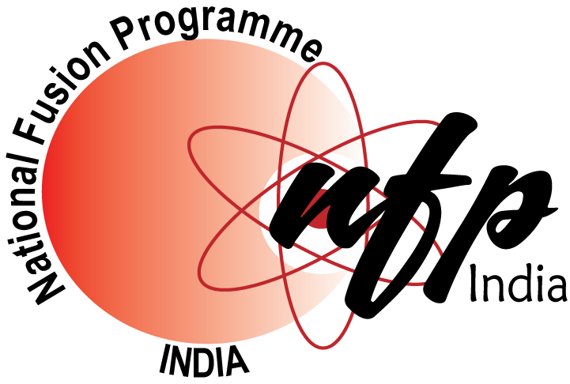
National Fusion Programme (NFP)
Internship Programme

Certificate of Undertaking
(To be submitted along with the application)

I, ________________________________________ hereby accept the NFP Internship for the period from ____________ to ___________. I/We also hereby agree to abide by the following rules of NFP pertaining to the NFP Internship.

- All research work carried out by the student during the course of the Internship will remain the sole property of NFP.
- The Internship student will be subject to performance reviews as and when deemed necessary by NFP/IPR.
- Publication (of any kind), presentation at national/international conference/ meetings/workshops/symposium of the research material generated under the Internship program requires prior written permission of NFP.
- Any of the above mentioned publication(s) should contain explicit acknowledgement to NFP.
- The final and binding decision regarding any publication related issue of the work carried out under the NFP Internship will rest with NFP and the IPR supervisor(s) of the Internship student.

Name of the Internship Student
Duration of Internship |  | From |  |  | DD/MM/YYYY |  |  | To |  | DD/MM/YYYY
Name of the Institution
Address
Name of the supervisor from the student’s Institution |  |  |  |  |  |  | Designation
E-mail |  |  |  |  |  | Phone/Mobile
Name of the Head of the Department of the student’s Institution |  |  |  |  |  |  | Designation
E-mail |  |  |  |  |  | Phone/Mobile

_________________________ _____________________________
Signature of Internship Student Signature of Supervisor from
Student’s Institution

Place :
Date : _______________________________
Signature of HOD of Student’s Institute
With official seal of the Institute

______________________________________________________________________________
To be filled only at the time of joining

Name of IPR Supervisor :
Division/Group :
Tel. No. :
________________________
Date : Signature of IPR Supervisor

Board Of Research in Fusion Science & Technology (NFP)
Institute For Plasma Research, Bhat, Near Indira Bridge, Gandhinagar 382 428, Gujarat
E-mail : <nfp.projects@gmail.com> Tel : 079-23962181/2182 ; Fax : 079-23962285

National Fusion Programme (NFP)
Institute For Plasma Research, Bhat, Near Indira Bridge, Gandhinagar 382 428, Gujarat
E-mail : <nfp.projects@gmail.com> Tel : 079-23962181 ; Fax : 079-23962285

